RECRUSIVE FEATURE SELECTION

The accuracy scores for different classifiers across various metrics. Here's a breakdown of the provided data:

Each row represents a classifier (Logistic, SVC, Random, DecisionTree).

Each column represents a metric (Logistic, SVMl, SVMnl, KNN, Navie, Decision, Random).

The values in the dataframe represent the accuracy scores for each classifier across each metric.

**Explanation: Feature n=6**

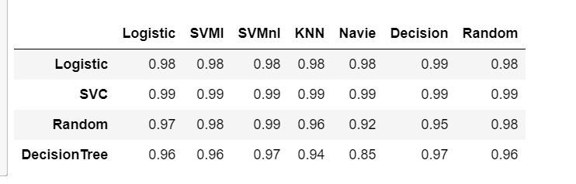

* The accuracy score for Logistic classifier across different metrics is 0.98 for Logistic, SVMl, SVMnl, KNN, and Navie, 0.99 for Decision, and 0.98 for Random.
* The accuracy score for SVC classifier across different metrics is 0.99 for Logistic, SVMl, SVMnl, KNN, Navie, Decision, and Random.
* The accuracy score for Random classifier across different metrics is 0.97 for Logistic, 0.98 for SVMl, 0.99 for SVMnl, 0.96 for KNN, 0.92 for Navie, 0.95 for Decisiontree , and 0.98 forRandom.
* The accuracy score for Decision tree classifier across different metrics is 0.96 for Logistic, SVMl,&random forest ,0.97 for SVMnl,decision tree,0.94 for KNN, 0.85 for Navie.
* This dataframe allows for easy comparison of the performance of different classifiers across multiple metrics. It seems like all classifiers perform relatively well across the metrics, with SVC achieving the highest accuracy scores consistently across all metrics.

**n=3**

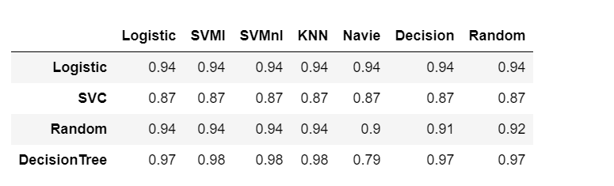

* The accuracy score for Logistic classifier across different metrics is 0.94 for Logistic, SVMl, SVMnl, KNN, Navie, Decision, and Random.
* The accuracy score for SVC classifier across different metrics is 0.87 for Logistic, SVMl, SVMnl, KNN, Navie, Decision, and Random.
* The accuracy score for Random classifier across different metrics is 0.94 for Logistic, SVMl, SVMnl, KNN,0.9 for Navie, 0.91 for Decision, and 0.92 for Random..
* The accuracy score for Decision tree classifier across different metrics is 0.97 for Logistic, decision,random,0.98 for SVMl,&KNN ,0.79 for Navie.
* This dataframe allows for easy comparison of the performance of different classifiers across multiple metrics. It seems like all classifiers perform relatively well across the metrics, with Decision tree(0.98) with svmnl,svml,knn achieving the highest accuracy scores consistently across all metrics.

**n=5**

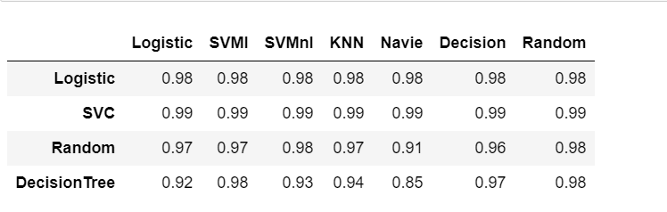

* The accuracy score for Logistic classifier across different metrics is 0.98 for Logistic, SVMl, SVMnl, KNN, Navie, Decision, and Random.
* The accuracy score for SVC classifier across different metrics is 0.99 for Logistic, SVMl, SVMnl, KNN, Navie, Decision, and Random.
* The accuracy score for Random classifier across different metrics is 0.97 for Logistic, SVMl, SVMnl, KNN,0.98 for svmnl & random ,0.91 for Navie, 0.96 for Decision, and 0.98 for Random..
* The accuracy score for Decision tree classifier across different metrics is 0.92 for Logistic, 0.98 for SVMl,0.93 for SVMnl,0.94 for KNN,0.85 for naïve ,0.97 for decision,0.98 for random.
* This dataframe allows for easy comparison of the performance of different classifiers across multiple metrics. It seems like all classifiers perform relatively well across the metrics, with SVC (0.99)achieving the highest accuracy scores consistently across all metrics.

Comparing these three dataframes, feature 5&6 has SVC Classifier 0.99 score with all metrics